**Assignment 8**

RITA FADLALLAH

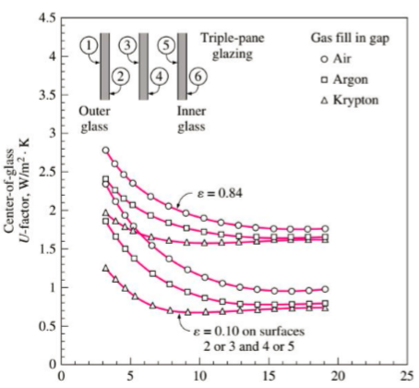**Question 1:** Using the diagrams given in the presentation calculate how much (%) is the effect of applying different modifications (changing the gas, adding an extra pane, using a low emissivity coating) on the U value with respect to a benchmark case of double layer with air and no coating ? (keep the gap thickness to be 13 mm)

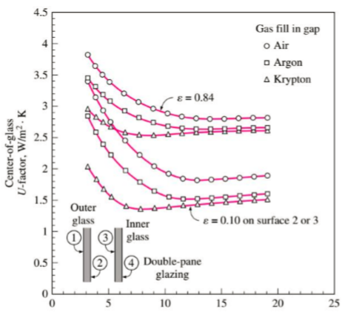

**13**

**13**

|  |  |  |  |  |  |  |  |  |  |  |  |  |
| --- | --- | --- | --- | --- | --- | --- | --- | --- | --- | --- | --- | --- |
| ɛ value | 0.84 | | | 0.1 | | | 0.84 | | | 0.1 | | |
| number of panes | 2 | 2 | 2 | 2 | 2 | 2 | 3 | 3 | 3 | 3 | 3 | 3 |
| Gas | air | argon | krypton | air | argon | krypton | air | argon | krypton | air | argon | krypton |
| U-value | 2.8 | 2.65 | 2.6 | 1.8 | 1.5 | 1.4 | 1.8 | 1.7 | 1.6 | 1 | 0.8 | 0.7 |
| % of change |  | 5.63 | 7.14 | 35.71 | 46.42 | 50 | 35.71 | 39.28 | 42.85 | 64.28 | 71.42 | 75 |

**Question 2**

Consider the house that we analyzed in the last two examples, calculate the heating and cooling load of the other windows which are fixed 14.4 m2 on the west, fixed 3.6 m2 on the south and an operable 3.6 m2 on the south (the same window and frame type). How much does the total value change if I change the frame of the window from wooden one to aluminum?

**Location:** Piacenza; **Latitude:** 44.92 N; **Longitudinal:** 9.73 E; **Elevation:** 138

T (heat)= 24°C; T (cool)= 20°C   
Therefore, ∆Theating= 20- (-4.8)= 24.8°C ∆Tcooling= 31.9- 24= 7.9°C

DR= 11.9°C (from table)

Calculating load of **fixed Wooden** window on the **WEST= 14.4 m2:**

1. Cooling

CFht = U(∆Tcooling -0.46*DR) = 2.84 (7.9-0.46*11.9) = 6.9 W/m2

CFip = PXI * SHGC* IAC * FFs = 747* 0.54* 1* 0.56= 217.8 W/m2

CF (total)= 224.7 W/m2

**Q (cooling)= CF(total) * A= 224.7* 14.4= 3235.7W**

1. Heating

HF= U* ∆Theating = 2.84* 24.8= 70.4 W/m2

**Q (heating)= HF* A= 70.4*14.4= 1013.8 W**

Calculating load of **fixed Aluminum** window on the **WEST= 14.4 m2:**

1. Cooling

CFht = U(∆Tcooling -0.46*DR) = 3.61 (7.9-0.46*11.9) = 8.8 W/m2

CFip = PXI * SHGC* IAC * FFs = 747* 0.56* 1* 0.56= 234.3 W/m2

CF (total)= 243.1 W/m2

**Q (cooling)= CF(total) * A= 243.1* 14.4= 3500.64 W**

1. Heating

HF= U* ∆Theating = 3.61* 24.8= 89.5 W/m2

**Q (heating)= HF* A= 89.5*14.4= 1288.8 W**

Calculating load of **fixed Wooden** window on the **SOUTH= 3.6 m2:**

1. Cooling

CFht = U(∆Tcooling -0.46*DR) = 2.84 (7.9-0.46*11.9) = 6.9 W/m2

CFip = PXI * SHGC* IAC * FFs = 557* 0.54* 1* 0.47= 141.4 W/m2

CF (total)= 148.3 W/m2

**Q (cooling)= CF(total) * A= 148.3* 3.6= 533.9 W**

1. Heating

HF= U* ∆Theating = 2.84* 24.8= 70.4 W/m2

**Q (heating)= HF* A= 70.4*3.6= 253.4 W**

Calculating load of **fixed Aluminum** window on the **SOUTH= 3.6 m2:**

1. Cooling

CFht = U(∆Tcooling -0.46*DR) = 3.61 (7.9-0.46*11.9) = 8.8 W/m2

CFip = PXI * SHGC* IAC * FFs = 557* 0.56* 1* 0.47= 146.6 W/m2

CF (total)= 155.4 W/m2

**Q (cooling)= CF(total) * A= 155.4* 3.6= 559.4 W**

1. Heating

HF= U* ∆Theating = 3.61* 24.8= 89.5 W/m2

**Q (heating)= HF* A= 89.5*3.6= 322.2 W**

Calculating load of **operable Wooden** window on the **SOUTH= 3.6 m2:**

1. Cooling

CFht = U(∆Tcooling -0.46*DR) = 2.87 (7.9-0.46*11.9) = 6.96 W/m2

CFip = PXI * SHGC* IAC * FFs = 557* 0.46* 1* 0.47= 120.4 W/m2

CF (total)= 127.4 W/m2

**Q (cooling)= CF(total) * A= 127.4* 3.6= 458.6 W**

1. Heating

HF= U* ∆Theating = 2.87* 24.8= 71.2 W/m2

**Q (heating)= HF* A= 71.2*3.6= 256.3 W**

Calculating load of **operable Aluminum** window on the **SOUTH= 3.6 m2:**

1. Cooling

CFht = U(∆Tcooling -0.46*DR) = 4.62 (7.9- 0.46*11.9) = 11.2 W/m2

CFip = PXI * SHGC* IAC * FFs = 557* 0.55* 1* 0.47= 143.98 W/m2

CF (total)= 155.2 W/m2

**Q (cooling)= CF(total) * A= 155.2* 3.6= 558.7 W**

1. Heating

HF= U* ∆Theating = 4.62* 24.8= 114.6 W/m2

**Q (heating)= HF* A= 114.6 *3.6= 412.6 W**